

**DEPARTMENT: ICT**

**PROGRAM: INFORMATION TECHNOLOGY**

**RQF LEVEL: 8**

**RQF LEVEL: 8**

**MODULE: CYBERSECURITY**

**Academic: 2024-2025**

**ASSISSGNMENT 1**

**Date: 15/03/2025**

**Name: NIYIGABA Claude**

**Reg No: 24RP14647**

**Email: niyigabaclaujesus@gmail.com**

**Q1.** **Which best practices used to detect and identify malwares?**

Detecting and identifying malware requires a combination of proactive measures, tools, and best practices. Here are the **best practices** used to detect and identify malware effectively:

1. **Use Antivirus and Anti-Malware Software**

* Install and regularly update reputable antivirus and anti-malware tools (e.g., Windows Defender, Malwarebytes, Kaspersky, Norton).
* Enable real-time scanning to detect threats as they occur.

1. **Keep Systems and Software Updated**

* Regularly update operating systems, applications, and firmware to patch vulnerabilities that malware exploits.
* Enable automatic updates where possible.

1. **Monitor Network Traffic**

* Use network monitoring tools (e.g., Wireshark, Zeek, or intrusion detection systems like Snort) to identify unusual traffic patterns.
* Look for connections to known malicious IP addresses or domains.

1. **Analyze System Behavior**

* Monitor system performance for unusual activity, such as:
  + High CPU, memory, or disk usage.
  + Unexpected processes or services running.
* Use tools like **Process Explorer** (Windows) or **htop** (Linux) to inspect running processes.

1. **Implement Endpoint Detection and Response (EDR)**

* Use EDR solutions to monitor endpoints for suspicious activity and respond to threats in real time.
* Examples: CrowdStrike, Microsoft Defender for Endpoint, SentinelOne.

1. **Enable Firewalls and Intrusion Prevention Systems (IPS)**

* Configure firewalls to block unauthorized access and monitor inbound/outbound traffic.
* Use IPS to detect and block known attack patterns.

1. **Conduct Regular Scans**

* Perform full system scans periodically to detect hidden malware.
* Use tools like **Malwarebytes** for additional scans.

1. **Use Sandboxing for Suspicious Files**

* Execute suspicious files in a secure, isolated environment (sandbox) to analyze their behavior.
* Tools: Cuckoo Sandbox, Joe Sandbox, or cloud-based solutions like Hybrid Analysis.

1. **Check for Indicators of Compromise (IOCs)**

* Look for known IOCs, such as:
  + Malicious file hashes (MD5, SHA-256).
  + Suspicious registry entries or file paths.
  + Known malicious domains or IP addresses.
* Use threat intelligence platforms like VirusTotal or AlienVault OTX to analyze IOCs.

1. **Monitor User Behavior**

* Educate users about phishing and social engineering attacks.
* Monitor for unusual user activity, such as:
  + Logins from unfamiliar locations or devices.
  + Unauthorized access to sensitive files.

1. **Implement Email Security Measures**

* Use email filtering tools to block phishing emails and malicious attachments.
* Train users to identify suspicious emails and avoid clicking on unknown links.

1. **Backup Data Regularly**

* Maintain regular backups of critical data and ensure they are stored securely.
* Test backups periodically to ensure they can be restored in case of a ransomware attack.

1. **Use Behavioral Analysis**

* Deploy tools that use machine learning and behavioral analysis to detect zero-day threats.
* Examples: Darktrace or Microsoft Defender for Endpoint.

1. **Leverage Threat Intelligence**

* Stay informed about the latest malware trends and threats by subscribing to threat intelligence feeds.
* Use platforms like VirusTotal, AlienVault OTX, or Recorded Future.

1. **Perform Regular Audits and Penetration Testing**

* Conduct security audits to identify vulnerabilities in your systems.
* Perform penetration testing to simulate attacks and identify weaknesses.

1. **Isolate and Investigate Infected Systems**

* If malware is detected, isolate the infected system from the network to prevent further spread.
* Use forensic tools (e.g., FTK Imager, Autopsy) to analyze the malware and determine its impact.

1. **Educate and Train Employees**

* Train employees on cybersecurity best practices, such as:
  + Avoiding suspicious downloads or links.
  + Recognizing phishing attempts.
  + Reporting unusual system behavior.

1. **Use Multi-Factor Authentication (MFA)**

Implement MFA to reduce the risk of unauthorized access, even if credentials are compromised.

1. **Monitor for Ransomware Indicators**

* Look for signs of ransomware, such as:
  + Encrypted files with unusual extensions.
  + Ransom notes or messages demanding payment.
* Use ransomware-specific detection tools like **RansomWhere?** or **CryptoPrevent**.

1. **Collaborate with Cybersecurity Experts**

If malware is detected, consult with cybersecurity professionals or incident response teams to mitigate the threat effectively.

**Q2.** **From one practice, screenshot ho to identify a malware.**

**Step 1**

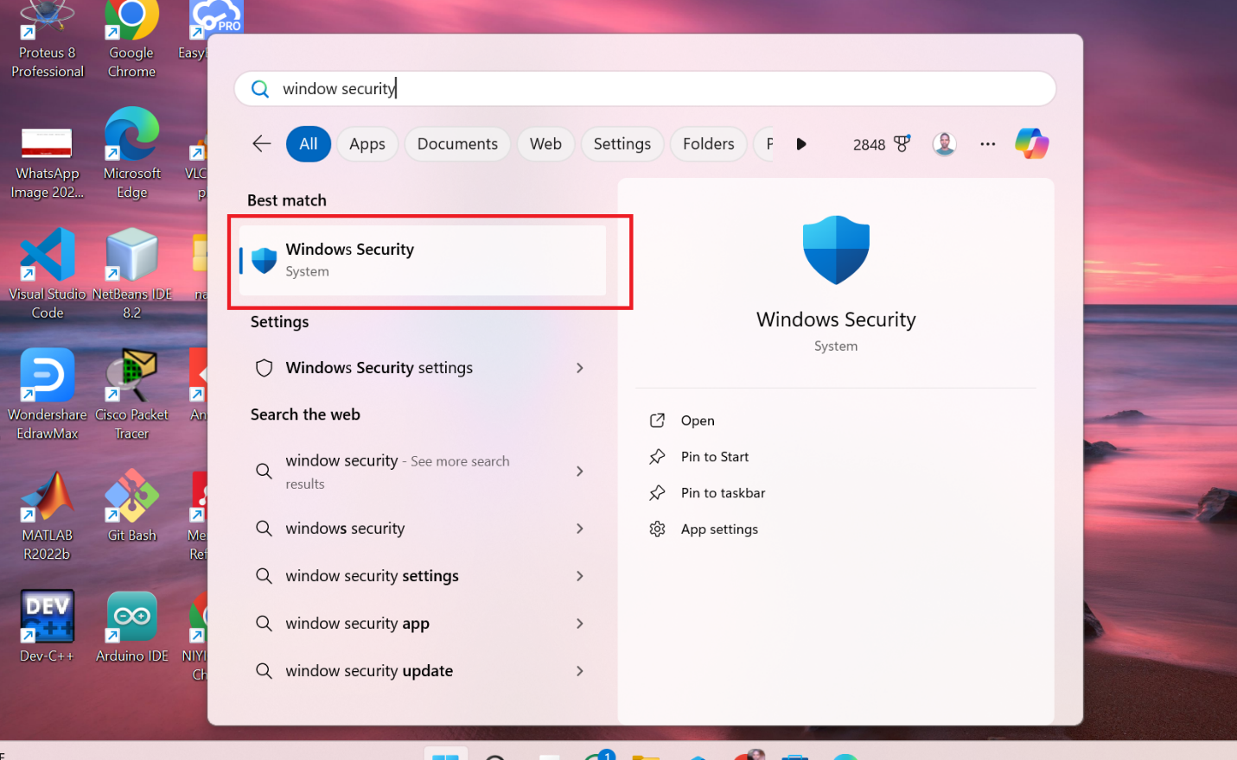

**Step 2**

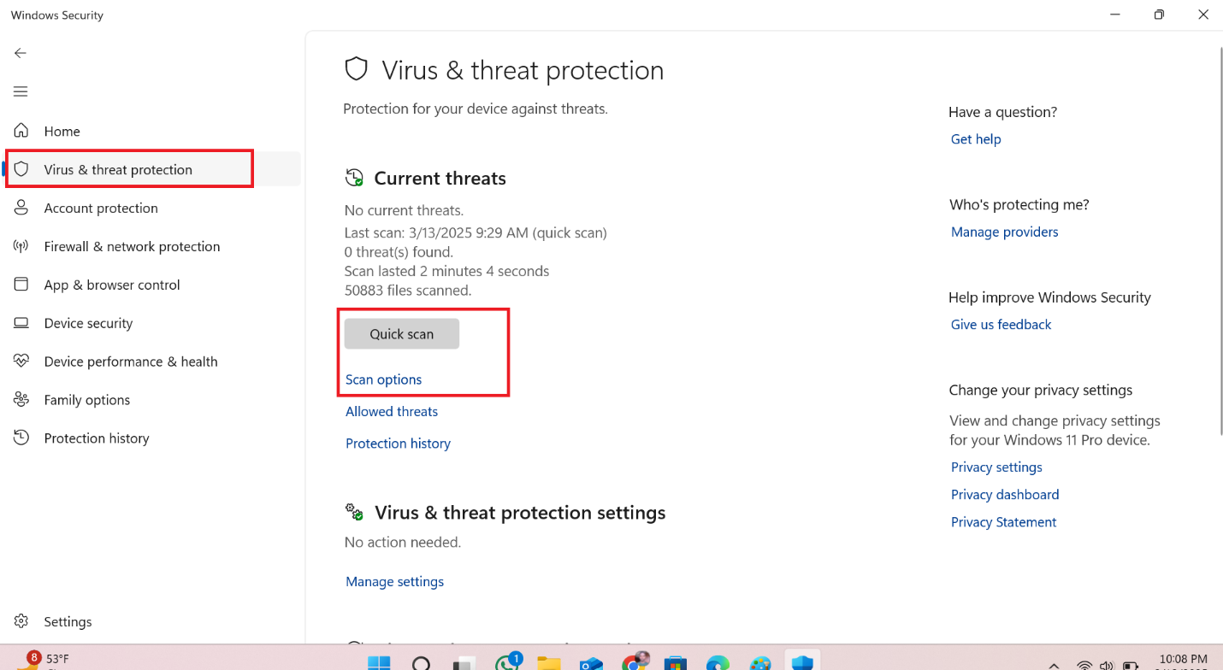

**Step 3**

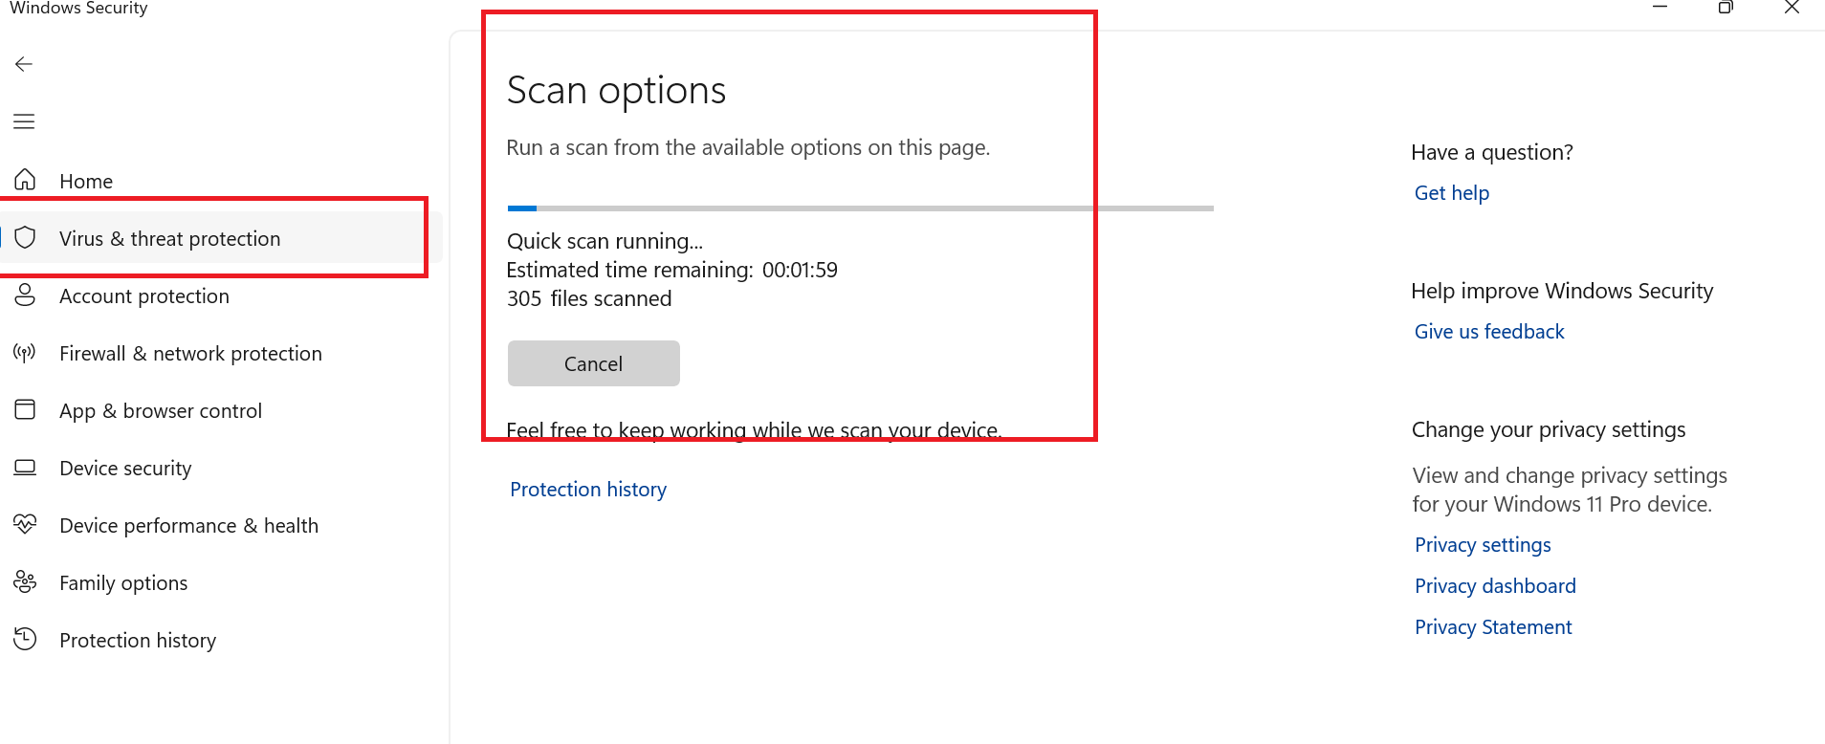

**Step 4**

